**Assignment 1**

**Submitted By**

Amna Tahir

**Submitted To**

Prof Abid Rafiq

**Roll Number**

BSITF18E014

**Department**



**CS & IT**

**SAP Introduction**

SAP stands for **Systems Applications and Products in data processing**. It was founded, in 1972, by five entrepreneurs(Dietmar Hopp, Hasso Plattner, Hans-Werner Hector, Klaus Tschira, and Claus Wellenreuther) in Germany.

SAP is a software that helps businesses thrive, innovate, and run efficient work processes daily. Today, it is manage by SAP SE, a European multinational software corporation. They are particularly, known for their multiple end-to-end application / service suites and have been expanding in scope covering new generation technologies. To visualize how big the **SAP software is, it was, stated that 77% of the world’s transaction revenue touches an SAP system.**

**SAP Modules**

SAP modules include a number of functional modules, which support transactions to execute key business processes, such as −

* 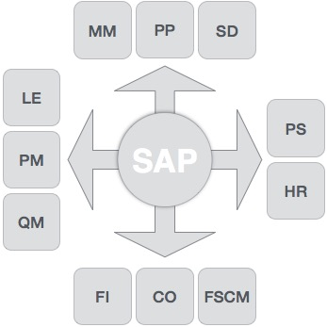Financial Accounting (FI)
* Financial Supply Chain Management (FSCM)
* Controlling (CO)
* Materials Management (MM)
* Sales and Distribution (SD)
* Logistics Execution (LE)
* Production Planning (PP)
* Quality Management (QM)
* Plant Maintenance (PM)
* Project System (PS)
* Human Resources (HR)

**Finance and Controlling (FICO)**

SAP FICO is a combination of two ERP modules, i.e., Finance Accounting (FI) and Controlling (CO).

**SAP FI** **(Financial Accounting)** is accountable for tracking the flow of financial data across the organization in a controlled manner and integrating all the information for effective strategic decision-making.

**Activities Involved in SAP FI**

* Financial Accounting Global Settings (Maintenance of Fiscal Year, Posting Periods, defining Document types, posting keys, Number ranges for documents)
* General Ledger Accounting (Creation of Chart of Accounts, Account groups, defining data transfer rules, creation of General Ledger Account)
* Tax Configuration & Creation and Maintenance of House of Banks
* Account Payables (Creation of Vendor Master data and vendor-related finance attributes like account groups and payment terms)
* Account Receivables (Creation of Customer Master data and customer-related finance attributes like account groups and payment terms
* Asset Accounting
* Integration with SD and MM

**SAP CO (Controlling)** module facilitates coordinating, monitoring, and optimizing all the processes in an organization. It controls the business flow in an organization. This module helps in analyzing the actual figures with the planned data and in planning business strategies.

Two kinds of elements are manage in CO:

* Cost elements
* Revenue elements

These elements are stored in the FI module.

**Activities Involved in SAP CO**

* Cost Element Accounting (Overview of the costs and revenues that occur in an organization)
* Cost Center Accounting
* Activity-Based-Accounting (Analyzes cross-departmental business processes)
* Internal Orders
* Product Cost Controlling (Calculates the costs that occur during the manufacture of a product or provision of a service)
* Profitability Analysis (Analyzes the profit or loss of an organization by individual market segments)
* Profit Center Accounting (Evaluates the profit or loss of individual, independent areas within an organization)

**Components of FICO**

* **SAP General Ledger:** The major aim of SAP general ledger accounting is to provide a system for managing all external accounts of an organization. Recording all the business transactions of an enterprise along with various other operation areas are manage by this SAP accounting module. It provides real-time assessment of cost accounting areas.
* **SAP Accounts Payable and Receivable:** While SAP accounts payable records all the components and data for vendors, SAP account receivable records all the components and data for customers. Balance sheets and account statements can be create using these modules.
* **SAP Bank Accounting:** This module is use to handle all bank accounting transactions. From managing bank master data, cash balance management to processing incoming and outgoing payments; everything can be manage using this module.
* **SAP Asset Accounting:** This module is design to manage fixed assets of organizations. The SAP financials system enables to manage and supervise fixed assets along with providing detailed information and reporting data.
* **SAP Funds Management:** This SAP accounting module supports all the related tasks in creating and managing budgets. Calculating revenues, expenditures and funds are included in the task lists of SAP funds management.
* **SAP Travel Management:** This SAP module accounts all the transactions related to corporate trips organized within and by the organization. Approvals, bookings, settlement and diverse travel expenditures are record and managed using the SAP travel management module.

**Sales & Distribution Management (SD)**

SAP SD is one of the most important modules in SAP. It has a high level of integration complexity. SAP SD is use by organizations to support sales and distribution activities of products and services, starting from enquiry to order and then ending with delivery.

SAP SD can monitor a huge amount of activities that take place in an organization such as products enquires, quotation (pre-sales activities), placing order, pricing, scheduling deliveries (sales activity), picking, packing, goods issue, shipment of products to customers, delivery of products and billings.

In all these processes, multiple modules are involved such as FI (Finance Accounting), CO (Controlling), MM (Material Management), PP (Production Planning), LE (Logistics Execution), etc., which shows the complexity of the integration involved.

**Activities Involved in SAP SD**

* Setting up Organization Structure (creation of new company, company codes, sales organization, distribution channels, divisions, business area, plants, sales area, maintaining sales offices, storage location)
* Assigning Organizational Units (Assignment of individual components created in the above activities with each other according to design like company code to company, sales organization to company code, distribution channel to sales organization, etc.)
* Defining Pricing Components (Defining condition tables, condition types, condition sequences)
* Setting up sales document types, billing types, and tax-related components
* Setting up Customer master data records and configuration

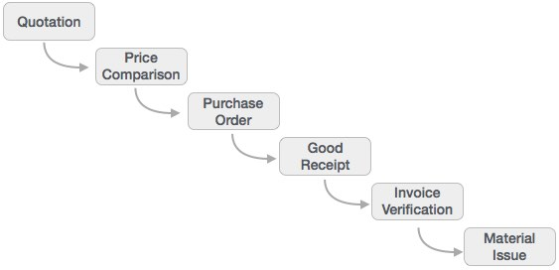**Material Management (MM)**

Material Management deals with movement of materials via other modules like logistics, supply chain management, sales and delivery, warehouse management, production and planning.

**Logistic Execution (LE)**

Logistic Execution can divided into two sub-modules, i.e., shipment of goods (purchase to procurement process) and warehouse management (storage of goods). These two modules are integrated with sale and distribution, material management, and production and planning.

**Supplier Relationship Management (SRM)**

As the name SRM suggests, this module deals with the effective and efficient transition of products and services between an organization and its suppliers. The main process covered in this section is procurement of products like direct materials, indirect materials, and services. This module can effectively integrate with planning, accounting, and inventory system.

**Customer Relationship Management (CRM)**

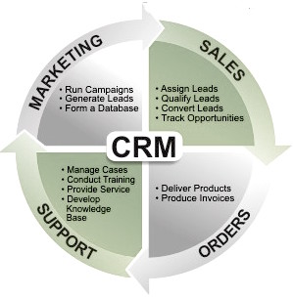CRM deals with end-to-end customer related processes. CRM is design to centralize the data related to all the customers associated with an organization. It helps an organization

* Maintain its sales, services, and build marketing strategies according the market demand and customer data analysis.
* Remain focused on its customers and via information analysis, help the business to know more about its customers.
* Improve sales and services, and building better relationships with customers.

**Human Resource (HR)**

The most important objective of master data administration in Human Resources is to enter employee-related data for administrative, time-recording and payroll purposes.

A new employee can be hire without using Recruitment. Instead, you can hire someone by running a personnel action in Personnel Administration, thereby creating the necessary data for the employee to be hired.

Employee data must be, kept current. After an employee is hired, circumstances can always arise which necessitate either the entry of new data or the correction of current data. For instance

* An employee moves to his or her new address must be stored in the system.
* An employee gets a pay hike at the start of the year. The new salary must be stored for the relevant date.
* An employee changes jobs within the organization. His or her organizational assignment, working time, and salary also change.
* Data can be stored for the past, present, or future.

The HR module is comprised of major areas of functionality known as sub-modules. The HR module is a true demonstration of the strength of the SAP product in Enterprise Resource Planning.

The HR system has very strong integration points (where data is passed back and forth without human intervention) with just about all of the other SAP modules. In addition, there is very tight integration amongst the HR sub-modules.

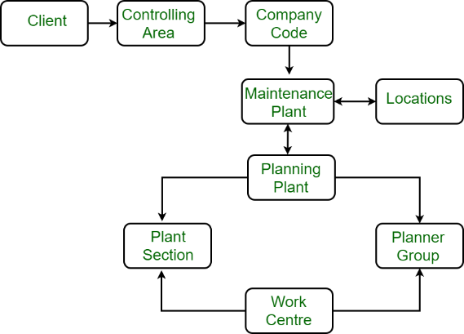**Plant Maintenance (PM)**

Plant maintenance is a type of module that provides an integrated solution, which supports the operational needs of an enterprise-wide system. This module includes all the products that covers all aspects for the maintenance of plant or equipment in good operating conditions to avoid production stoppage and loss. It also becomes integral to access the achievement of the process improvement.

**Advantages of Plant Maintenance:**

* It helps in reduction of breakdown losses.
* It helps in reduction of quality defects.
* It increases net quality profits.
* It reduces maintenance cost.

The major subsystems of a plant maintenance are :

Preventive maintenance control :

Preventive maintenance control enables the organization to lower repair cost by avoidance of down time, machine breakage and process variability. It also provide planning, scheduling and control of facilities.

Equipment tracking :

An equipment is a useful thing which needs to be protect and monitor. It’s cost constitute the single largest expenditure of an organization.

Component tracking :

Components are the subsets of larger equipment and also it deserve same amount of cost control expenditure. It enables expenditure managers to identify components with repair problems.

Plant maintenance calibration tracking :

It allows organizations to fully use their investments in the plant maintenance module.

Plant maintenance warranty claims tracking :

It is an administrative system to provide control of all items covered by manufacturer and vendor warranties. It includes the ability to establish the type and length of warranty.

Objectives of Plant Maintenance :

It helps in minimizing the loss of production time due to any equipment failure .

It helps in quality and product improvement.

It keeps all the assets in proper working conditions.

Advantages of Plant Maintenance :

It helps in reduction of breakdown losses.

It helps in reduction of quality defects.

It increases net quality profits.

It reduces maintenance cost.

Disadvantages of Plant Maintenance :

It increases investments in diagnostics equipment.

It also increases investment in staff training.

Saving potential that is not readily seen by the management.

**Quality Management (QM)**

Quality management is the act of overseeing all activities and tasks that must be, accomplished to maintain a desired level of excellence. This includes the determination of a quality policy, creating and implementing quality planning and assurance, and quality control and quality improvement. It is also, referred to as total quality management (TQM).

**Oracle E-Business Suite (EBS) Introduction**

Oracle E-Business Suite (EBS) version 12 is an internet-enabled product that can be manage from a single site. Version 12 is current as of 2018.

A company can operate a single data center with a single database, similar to other ERP products. The suite was launch in February 2007 and contains a number of product lines, which users can implement into their own businesses. Oracle EBS includes the company’s enterprise resource planning (ERP) product as well as supply chain management (SCM) and customer relationship management (CRM) applications. Each application is license separately so companies can select the combination that is suitable for their business processes.

The applications found in the Oracle EBS include Oracle CRM, Oracle Financials, Oracle Human Resource Management System (HRMS), Oracle Logistics, Oracle Supply Chain Applications, Oracle Order Management, Oracle Transportation Management, and Oracle Warehouse Management System.

**Oracle CRM**

The Oracle CRM application provides front-office functions, which help businesses to increase customers and [customer loyalty](https://www.thebalancesmb.com/small-business-info-4161643) and satisfaction. The basic functionality includes marketing, order capture, [contracts](https://www.thebalancesmb.com/contract-termination-2221030), field service, and call center functionality. [The CRM application](https://www.thebalancesmb.com/crm-customer-relationship-management-2947184) also includes internet-focused products such as catalogs, content management, and quote and order management.

**Oracle Financials**

The Financials applications include General Ledger, [Cash Management](https://www.thebalancesmb.com/cash-management-is-important-for-your-small-business-393118), Payables, Receivables, [Fixed Assets](https://www.thebalancesmb.com/current-assets-398163), Treasury, [Property Management](https://www.thebalancesmb.com/is-quicken-rental-property-manager-any-good-14041), Financial Analyzer, and a self-service expenses function.

**Human Resource Management System (HRMS)**

The HRMS application helps companies manage the recruit-to-retire process. The application gives users a real-time view of all HR activities, including recruiting, time management, [training](https://www.thebalancesmb.com/global-learning-center-4161438), compensation, benefits, and payroll. The HRMS suite integrates fully with the other EBS applications and supplies users with an analytics package that allows the extraction of HR data with ease.

**Supply Chain Applications**

Supply chain applications power information-driven supply chains. Companies can predict market requirements, innovate in response to volatile market conditions, and align operations across global networks. Oracle offers industry-specific solutions that include product development, demand management, sales, and operations planning, transportation management, and [supply management](https://www.thebalancesmb.com/strategic-supply-chain-management-2221231).

**Warehouse Management System**

Oracle’s [Warehouse Management System](https://www.thebalancesmb.com/implementing-a-warehouse-management-system-wms-2221330) allows the coordinated movement of goods and information throughout the extended distribution process. The module provides [business processes](https://www.thebalancesmb.com/creating-a-document-management-system-2948084) that can deliver efficient utilization of employees, equipment, and space in the distribution process. Benefits include an acceleration of the flow of products [through the supply chain](https://www.thebalancesmb.com/reducing-waste-in-the-supply-chain-2221088) while reducing lead times and releasing [working capital](https://www.thebalancesmb.com/capital-investment-2948114), real-time inventory management, cross-docking, pick-by-line, advanced ship notices (ASN), [inbound](https://www.thebalancesmb.com/inbound-quality-inspections-2221196) planning, and yard management.

**What is Microsoft Dynamics 365 “Common Data Model”?**

Usually, it is the case with enterprise software foundation, that is the data handling techniques and the database, format itself is specific and often unique to the software with which it will be used thereby restricting the application’s compatibility with other external apps that you may prefer using.

Furthermore, customize databases are challenging to integrate and upgrade and therefore, Microsoft seems to be trying to take a different direction and move to standardized and consistent database schematics. The entire customer base can use any new solution that Microsoft deploys under the Dynamics 365 umbrella. The only difference being that users will browse applications through a new store known as Microsoft App-Source.

Therefore, the Common Data Model will allow integration with all Microsoft applications as well as any other applications using a standard API.

**What are the Uses for Microsoft Dynamics 365?**

Uses of Microsoft Dynamics 365:

* Bringing your business together as a cohesive unit by connecting people, processes, and data across many applications, including Microsoft Dynamics 365, Office 365, LinkedIn, and Azure.
* Making smarter decisions with built-in AI, analytics, and guided action suggestions.
* Adapting the application to your needs rather than changing your business methodology. You can integrate most applications with existing systems or even customize with Microsoft Power Platform.
* Modernize your approach by incorporating AI, mixed reality, social, and mobile capabilities for progressive business innovation.

**The Different Editions of Microsoft Dynamics 365?**

Dynamics 365 is sold in two main versions, the Business Edition for small and medium-sized enterprises (SMEs or SMBs), and the Enterprise Edition intended for medium to large-sized organizations.

**Dynamics 365, Enterprise Edition**

The Dynamics 365 Enterprise Edition includes Dynamics CRM applications (field service, sales, project service automation, and customer service) as well as Microsoft PowerApps. This also includes Microsoft’s top of the line ERP solution, Dynamics 365 for operations.

1. **Finance and Operations**

Formerly known as Microsoft Dynamics AX, the operations module contains all of the [finance and operations](https://dynamics.folio3.com/fasttrack-365-finance-operations/) functionality of Dynamics AX.

1. **Sales**

* The CRM component of Dynamics 365 offers all of the lead management and sales process functionality you need in sales (more specifically, the salesperson)
* Marketing
* Microsoft Dynamics

1. **Marketing**

No longer exists as a separate module. Dynamics 365, in partnership with Adobe, offers a more comprehensive and at the same time, integrated marketing tool.

1. **Customer Service**

Integrates CRM functionality, new functionality, existing Parature functionality, and more Microsoft partnerships.

1. **Project Service**

Allows for estimating and scheduling projects in Dynamics 365. Perfect for professional service organizations.

1. **Field Service**

This module leverages the mobility of the Microsoft cloud and delivers extra features required daily by field staff.

1. **Talent**

The HCM module of Dynamics 365 does not come bundled with the software and can be purchase separately.

1. **Retail**

The Retail (POS) module of Dynamics 365 does not come bundled with the software and can be purchase separately.

**Dynamics 365, Business Edition**

The Business Edition of Dynamics 365 is the evolution of project Madeira, the cloud-based ERP/CRM. Microsoft recommends Dynamics 365, Business Edition for companies with employees ranging from 100 to 250. It has three modules:

1. **Finance & Operations**

The finance module is base, on Microsoft Dynamics NAV, albeit with certain functionalities removed such as the manufacturing module.

1. **Sales**

The sales module of Dynamics 365, Business Edition is, based on Dynamics CRM and optimized for SMB customers. That is to say, the level of customers catered to by a small or medium business.

1. **Marketing**

The module will be a partnership with Adobe, much like the Enterprise edition.